A fuzzy logic controller for PLC in SCL (ST)

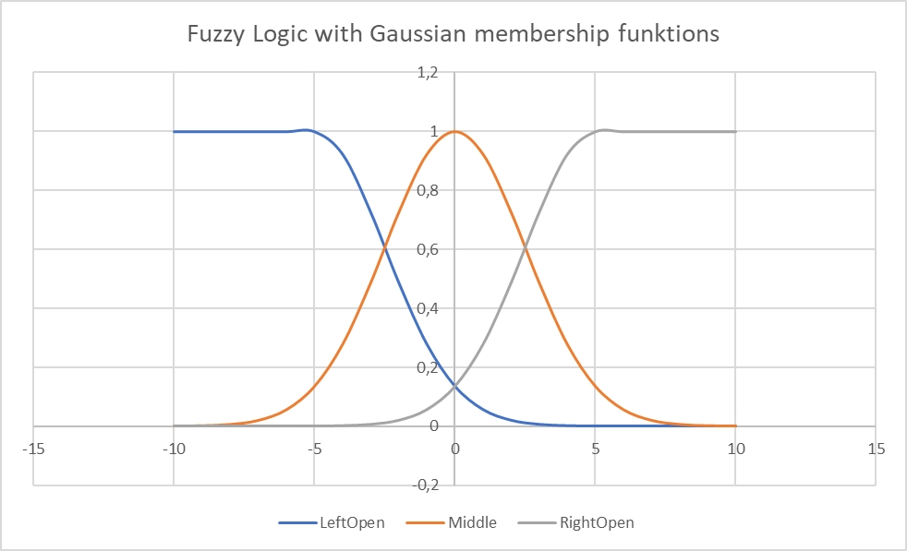
Fuzzy Logic Controller Memberships
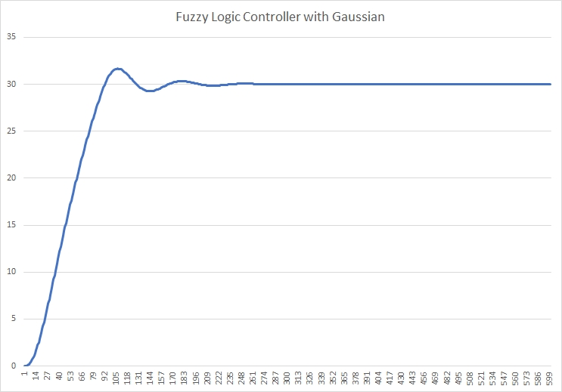
Step Response

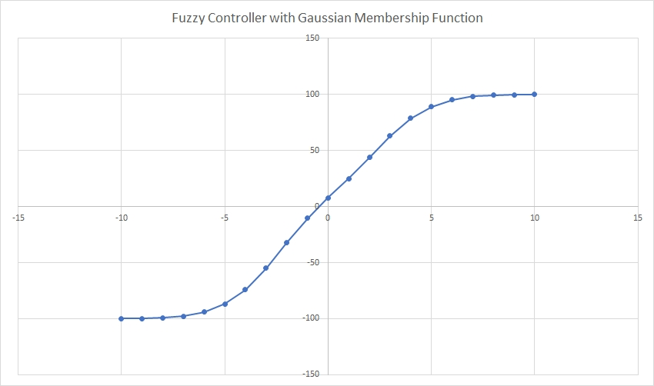
Transfer function of the Fuzzy Controller

Listing 1 SCL Example:

FUNCTION_BLOCK gauss_membership_leftopen
VAR_INPUT
x : REAL;
mean : REAL;
sigma : REAL;
END_VAR

VAR_OUTPUT
membership_value : REAL;
END_VAR

IF x < mean THEN
membership_value := 1.0;
ELSE
membership_value := EXP(-0.5 * POWER((x - mean) / sigma, 2));
END_IF

END_FUNCTION_BLOCK

FUNCTION_BLOCK gauss_membership
VAR_INPUT
x : REAL;
mean : REAL;
sigma : REAL;
END_VAR

VAR_OUTPUT
membership_value : REAL;
END_VAR

membership_value := EXP(-0.5 * POWER((x - mean) / sigma, 2));

END_FUNCTION_BLOCK

FUNCTION_BLOCK gauss_membership_rightopen
VAR_INPUT
x : REAL;
mean : REAL;
sigma : REAL;
END_VAR

VAR_OUTPUT
membership_value : REAL;
END_VAR

IF x > mean THEN
membership_value := 1.0;
ELSE
membership_value := EXP(-0.5 * POWER((x - mean) / sigma, 2));
END_IF

END_FUNCTION_BLOCK

FUNCTION PT2_Simulation : REAL
VAR_INPUT
ControlInput : REAL;
END_VAR

VAR
deltaT : REAL := 1.0;
k1 : REAL := 82.0 / 100;
k2 : REAL := 1.0;
k3 : REAL := 1.0;
T1 : REAL := 100.0;
T2 : REAL := 8.0;
T3 : REAL := 10.0;
x1_k : REAL := 0;
x2_k : REAL := 0;
x3_k : REAL := 0;
x1_dot : REAL;
x2_dot : REAL;
x3_dot : REAL;
END_VAR

x1_dot := (k1 * ControlInput - x1_k) / T1;
x1_k := x1_dot * deltaT + x1_k;

x2_dot := (k2 * x1_k - x2_k) / T2;
x2_k := x2_dot * deltaT + x2_k;

x3_dot := (k3 * x2_k - x3_k) / T3;
x3_k := x3_dot * deltaT + x3_k;

PT2_Simulation := x3_k;
END_FUNCTION

FUNCTION fuzzy_control : REAL
VAR_INPUT
e : REAL;
mean_left : REAL;
sigma_left : REAL;
mean_mid : REAL;
sigma_mid : REAL;
mean_right : REAL;
sigma_right : REAL;
END_VAR

VAR
left : REAL;
middle : REAL;
right : REAL;
numerator : REAL;
denominator : REAL;
y : REAL;
END_VAR

left := gauss_membership_leftopen(e, mean_left, sigma_left);
middle := gauss_membership(e, mean_mid, sigma_mid);
right := gauss_membership_rightopen(e, mean_right, sigma_right);

numerator := left * -70.0 + middle * 0 + right * 70.0;
denominator := left + middle + right;

IF denominator <> 0 THEN
y := numerator / denominator;
ELSE
y := 0;
END_IF

fuzzy_control := y;
END_FUNCTION

PROGRAM Main
VAR
loop : INT := 0; // Loop counter
w : REAL := 30.0; // Setpoint or desired output
y : REAL := 0.0; // Output of the system
x : REAL := 0.0; // Input to the system (state variable)
e : REAL := 0.0; // Error signal
factor : REAL; // Difference between the setpoint and the final system output
END_VAR

// Loop for PT2 system simulation and fuzzy control
FOR loop := 0 TO 499 DO
// Simulate the PT2 system and calculate the error signal
x := PT2_Simulation(y); // Simulate the PT2 system and update the state variable
e := w - x; // Calculate the error signal

// Apply fuzzy control to calculate the control signal
// Uncomment the following line to apply fuzzy control with a constant offset
y := fuzzy_control(e + 2.66); // Apply fuzzy control with a constant offset
// y := fuzzy_control(e); // Apply fuzzy control

// Print epoch information (iteration number) and system variables
// (Replace PRINT with appropriate function to output to PLC's diagnostic or HMI)
// PRINT("epoch = %d w = %.5f, e = %.5f, x = %.5f, y = %.5f", loop, w, e, x, y);
END_FOR

// Calculate the difference between the setpoint and the final system output
factor := w - x;

// Print the difference between the setpoint and the final system output
// (Replace PRINT with appropriate function to output to PLC's diagnostic or HMI)
// PRINT("factor = %.5f", factor);

// End of program
END_PROGRAM

Listing 2 Ansi C Example:
/*

Software: Fuzzy Test of Gaussian membership functions

Autor: Josef Bernhardt www.bernhardt.de

Date: 27.01.2023

Codeblocks ANSI C Enviroment for test

E-mail: josef@bernhardt.de for a complete control program

*/

#include <stdio.h>
#include <math.h>

// Mean and standard deviation for the left side of the x axis
float mean_left = -5; // Mean value for the left side of the x axis
float sigma_left = 2.5; // Standard deviation for the left side of the x axis

// Mean and standard deviation for the middle of the x axis
float mean_mid = 0.0; // Mean value for the middle of the x axis
float sigma_mid = 2.5; // Standard deviation for the middle of the x axis

// Mean and standard deviation for the right side of the x axis
float mean_right = 5.0; // Mean value for the right side of the x axis
float sigma_right = 2.5; // Standard deviation for the right side of the x axis

// This function calculates the membership value of a given input
// 'x' in a left-open Gaussian membership function.
// The left-open Gaussian membership function returns 1.0 for
// input values less than the mean,
// and the standard Gaussian membership function value otherwise.
float gauss_membership_leftopen(float x, float mean, float sigma) {
if (x < mean) {
return 1.0; // Outside the interval, return 0
}
return exp(-0.5 * pow((x - mean) / sigma, 2));
}

// This function calculates the membership value of a given input 'x'
// in a standard Gaussian membership function.
// The standard Gaussian membership function is continuous and
// returns a value based on the input, mean, and standard deviation.
float gauss_membership(float x, float mean, float sigma) {
return exp(-0.5 * pow((x - mean) / sigma, 2));
}

// This function calculates the membership value of a given input 'x'
// in a right-open Gaussian membership function.
// The right-open Gaussian membership function returns 1.0 for
// input values greater than the mean,
// and the standard Gaussian membership function value otherwise.
float gauss_membership_rightopen(float x, float mean, float sigma) {
if (x > mean) {
return 1.0; // Outside the interval, return 0
}
return exp(-0.5 * pow((x - mean) / sigma, 2));
}

// This function calculates the control signal (y) based on the error signal (e) using fuzzy logic.
float fuzzy_control(float e) {
// Calculate the membership values for the error signal in different regions of the fuzzy sets.
float left = gauss_membership_leftopen(e, mean_left, sigma_left); // Membership value for the left region
float middle = gauss_membership(e, mean_mid, sigma_mid); // Membership value for the middle region
float right = gauss_membership_rightopen(e, mean_right, sigma_right);// Membership value for the right region

// Calculate the weighted sum of membership values to determine the control signal.
float numerator = left * -70.0 + middle * 10 + right * 70.0; // Weighted sum of membership values
float denominator = left + middle + right; // Sum of membership values

float y; // Control signal

// Avoid division by zero by checking if the denominator is zero.
if (denominator != 0) {
// Calculate the control signal as the ratio of the weighted sum to the sum of membership values.
y = numerator / denominator;
} else {
// If the denominator is zero, set the control signal to zero to avoid undefined behavior.
y = 0;
}

// Uncomment the following line to print the membership values for debugging purposes.
// printf("The membership for e = %.5f, y = %.5f, left = %.5f middle = %.5f right = %.5f\n", e, y, left, middle, right);

return y; // Return the control signal.
}

// This function simulates a second-order system using a discrete-time approach (Euler integration).
float PT2_Simulation(float ControlInput) {
// Parameters
const float deltaT = 1.0; // Time step (max 10)
const float k1 = 82.0 / 100; // Gain factor
const float k2 = 1.0; // Gain factor
const float k3 = 1.0; // Gain factor
const float T1 = 100.0; // Time constant
const float T2 = 8.0; // Time constant
const float T3 = 10.0; // Time constant

// Variables
static float x1_k = 0; // State variable 1 at time k
static float x2_k = 0; // State variable 2 at time k
static float x3_k = 0; // State variable 3 at time k
static float x1_dot; // Rate of change of state variable 1
static float x2_dot; // Rate of change of state variable 2
static float x3_dot; // Rate of change of state variable 3

// Model equations using Euler integration
x1_dot = (k1 * ControlInput - x1_k) / T1; // Rate of change of state variable 1
x1_k = x1_dot * deltaT + x1_k; // Update state variable 1 using Euler integration

x2_dot = (k2 * x1_k - x2_k) / T2; // Rate of change of state variable 2
x2_k = x2_dot * deltaT + x2_k; // Update state variable 2 using Euler integration

x3_dot = (k3 * x2_k - x3_k) / T3; // Rate of change of state variable 3
x3_k = x3_dot * deltaT + x3_k; // Update state variable 3 using Euler integration

return x3_k; // Return the output of the system (state variable 3 at time k)
}

// Main function to demonstrate the fuzzy controller simulation and PT2 system simulation.
int main() {

// Dateinamen festlegen
char *filename = "ascii_values.csv";

// Datei zum Schreiben öffnen
FILE *file = fopen(filename, "w");

// Überprüfen, ob die Datei erfolgreich geöffnet wurde
if (file == NULL) {
printf("Fehler beim Öffnen der Datei.");
return 1;
}

int loop = 0; // Loop counter

float w = 30.0; // Setpoint or desired output
float y = 0; // Output of the system
float x = 0; // Input to the system (state variable)
float e = 0; // Error signal

// fprintf(file,"w x y");

// Loop for PT2 system simulation and fuzzy control
for (loop = 0; loop < 600; loop++) {
// Simulate the PT2 system and calculate the error signal
x = PT2_Simulation(y); // Simulate the PT2 system and update the state variable
e = w - x; // Calculate the error signal

// Apply fuzzy control to calculate the control signal
// Uncomment the following line to apply fuzzy control with a constant offset
y = fuzzy_control(e +2.32); // Apply fuzzy control with a constant offset
// y = fuzzy_control(e); // Apply fuzzy control

// Print epoch information (iteration number) and system variables
printf("epoch = %d w = %.5f, e = %.5f, x = %.5f, y = %.5f \n", loop, w, e, x, y);
// fprintf(file,"epoch = %d w = %.5f, e = %.5f, x = %.5f, y = %.5f \n", loop, w, e, x, y);
fprintf(file,"%.5f %.5f %.5f \n", w, x, y);

}

// Print the difference between the setpoint and the final system output
printf("e = %.5f",e);

// system("pause");
printf("Controller characteristic curve\n");
printf("float trainingPatterns[MAX_PATTERNS][MAX_INPUT_NEURONS] = {");
for (float ll = -10; ll < 11; ll+=1.0)
{
y = fuzzy_control(ll);
printf("{%.5f} , ",ll);
}
printf("};\n");
printf("float targetOutputs[MAX_PATTERNS][MAX_OUTPUT_NEURONS] = {");
for (float ll = -10; ll < 11; ll+=1.0)
{
y = fuzzy_control(ll);
printf("{%.7f}, ",y/100.0);
}
printf("};\n");

// Datei schließen
fclose(file);

system("pause");
return 0; // Return 0 to indicate successful execution
}

/*

Controller characteristic curve

e = -10.000, y = -99.966
e = -9.000, y = -99.847
e = -8.000, y = -99.406
e = -7.000, y = -98.053
e = -6.000, y = -94.673
e = -5.000, y = -88.024
e = -4.000, y = -76.627
e = -3.000, y = -59.085
e = -2.000, y = -37.876
e = -1.000, y = -17.649
e = 0.000, y = 0.000
e = 1.000, y = 17.649
e = 2.000, y = 37.876
e = 3.000, y = 59.085
e = 4.000, y = 76.627
e = 5.000, y = 88.024
e = 6.000, y = 94.673
e = 7.000, y = 98.053
e = 8.000, y = 99.406
e = 9.000, y = 99.847
e = 10.000, y = 99.966

example loop

epoch = 472 w = 30.00000, e = 0.00992, x = 29.99008, y = 36.58100
epoch = 473 w = 30.00000, e = 0.00999, x = 29.99001, y = 36.58207
epoch = 474 w = 30.00000, e = 0.01005, x = 29.98995, y = 36.58303
epoch = 475 w = 30.00000, e = 0.01011, x = 29.98989, y = 36.58385
epoch = 476 w = 30.00000, e = 0.01016, x = 29.98984, y = 36.58455
epoch = 477 w = 30.00000, e = 0.01020, x = 29.98980, y = 36.58515
epoch = 478 w = 30.00000, e = 0.01023, x = 29.98977, y = 36.58562
epoch = 479 w = 30.00000, e = 0.01025, x = 29.98975, y = 36.58596
epoch = 480 w = 30.00000, e = 0.01027, x = 29.98973, y = 36.58619
epoch = 481 w = 30.00000, e = 0.01027, x = 29.98973, y = 36.58630
epoch = 482 w = 30.00000, e = 0.01027, x = 29.98973, y = 36.58630
epoch = 483 w = 30.00000, e = 0.01027, x = 29.98973, y = 36.58619
epoch = 484 w = 30.00000, e = 0.01025, x = 29.98975, y = 36.58599
epoch = 485 w = 30.00000, e = 0.01023, x = 29.98977, y = 36.58568
epoch = 486 w = 30.00000, e = 0.01021, x = 29.98979, y = 36.58529
epoch = 487 w = 30.00000, e = 0.01017, x = 29.98983, y = 36.58480
epoch = 488 w = 30.00000, e = 0.01014, x = 29.98986, y = 36.58424
epoch = 489 w = 30.00000, e = 0.01009, x = 29.98991, y = 36.58362
epoch = 490 w = 30.00000, e = 0.01005, x = 29.98995, y = 36.58294
epoch = 491 w = 30.00000, e = 0.01000, x = 29.99000, y = 36.58221
epoch = 492 w = 30.00000, e = 0.00994, x = 29.99006, y = 36.58142
epoch = 493 w = 30.00000, e = 0.00989, x = 29.99011, y = 36.58060
epoch = 494 w = 30.00000, e = 0.00983, x = 29.99017, y = 36.57975
epoch = 495 w = 30.00000, e = 0.00977, x = 29.99023, y = 36.57888
epoch = 496 w = 30.00000, e = 0.00971, x = 29.99029, y = 36.57800
epoch = 497 w = 30.00000, e = 0.00965, x = 29.99035, y = 36.57713
epoch = 498 w = 30.00000, e = 0.00960, x = 29.99040, y = 36.57625
epoch = 499 w = 30.00000, e = 0.00954, x = 29.99046, y = 36.57541

*/

Listing 2:

