A neural network for a fuzzy logic controller in ANSI C:
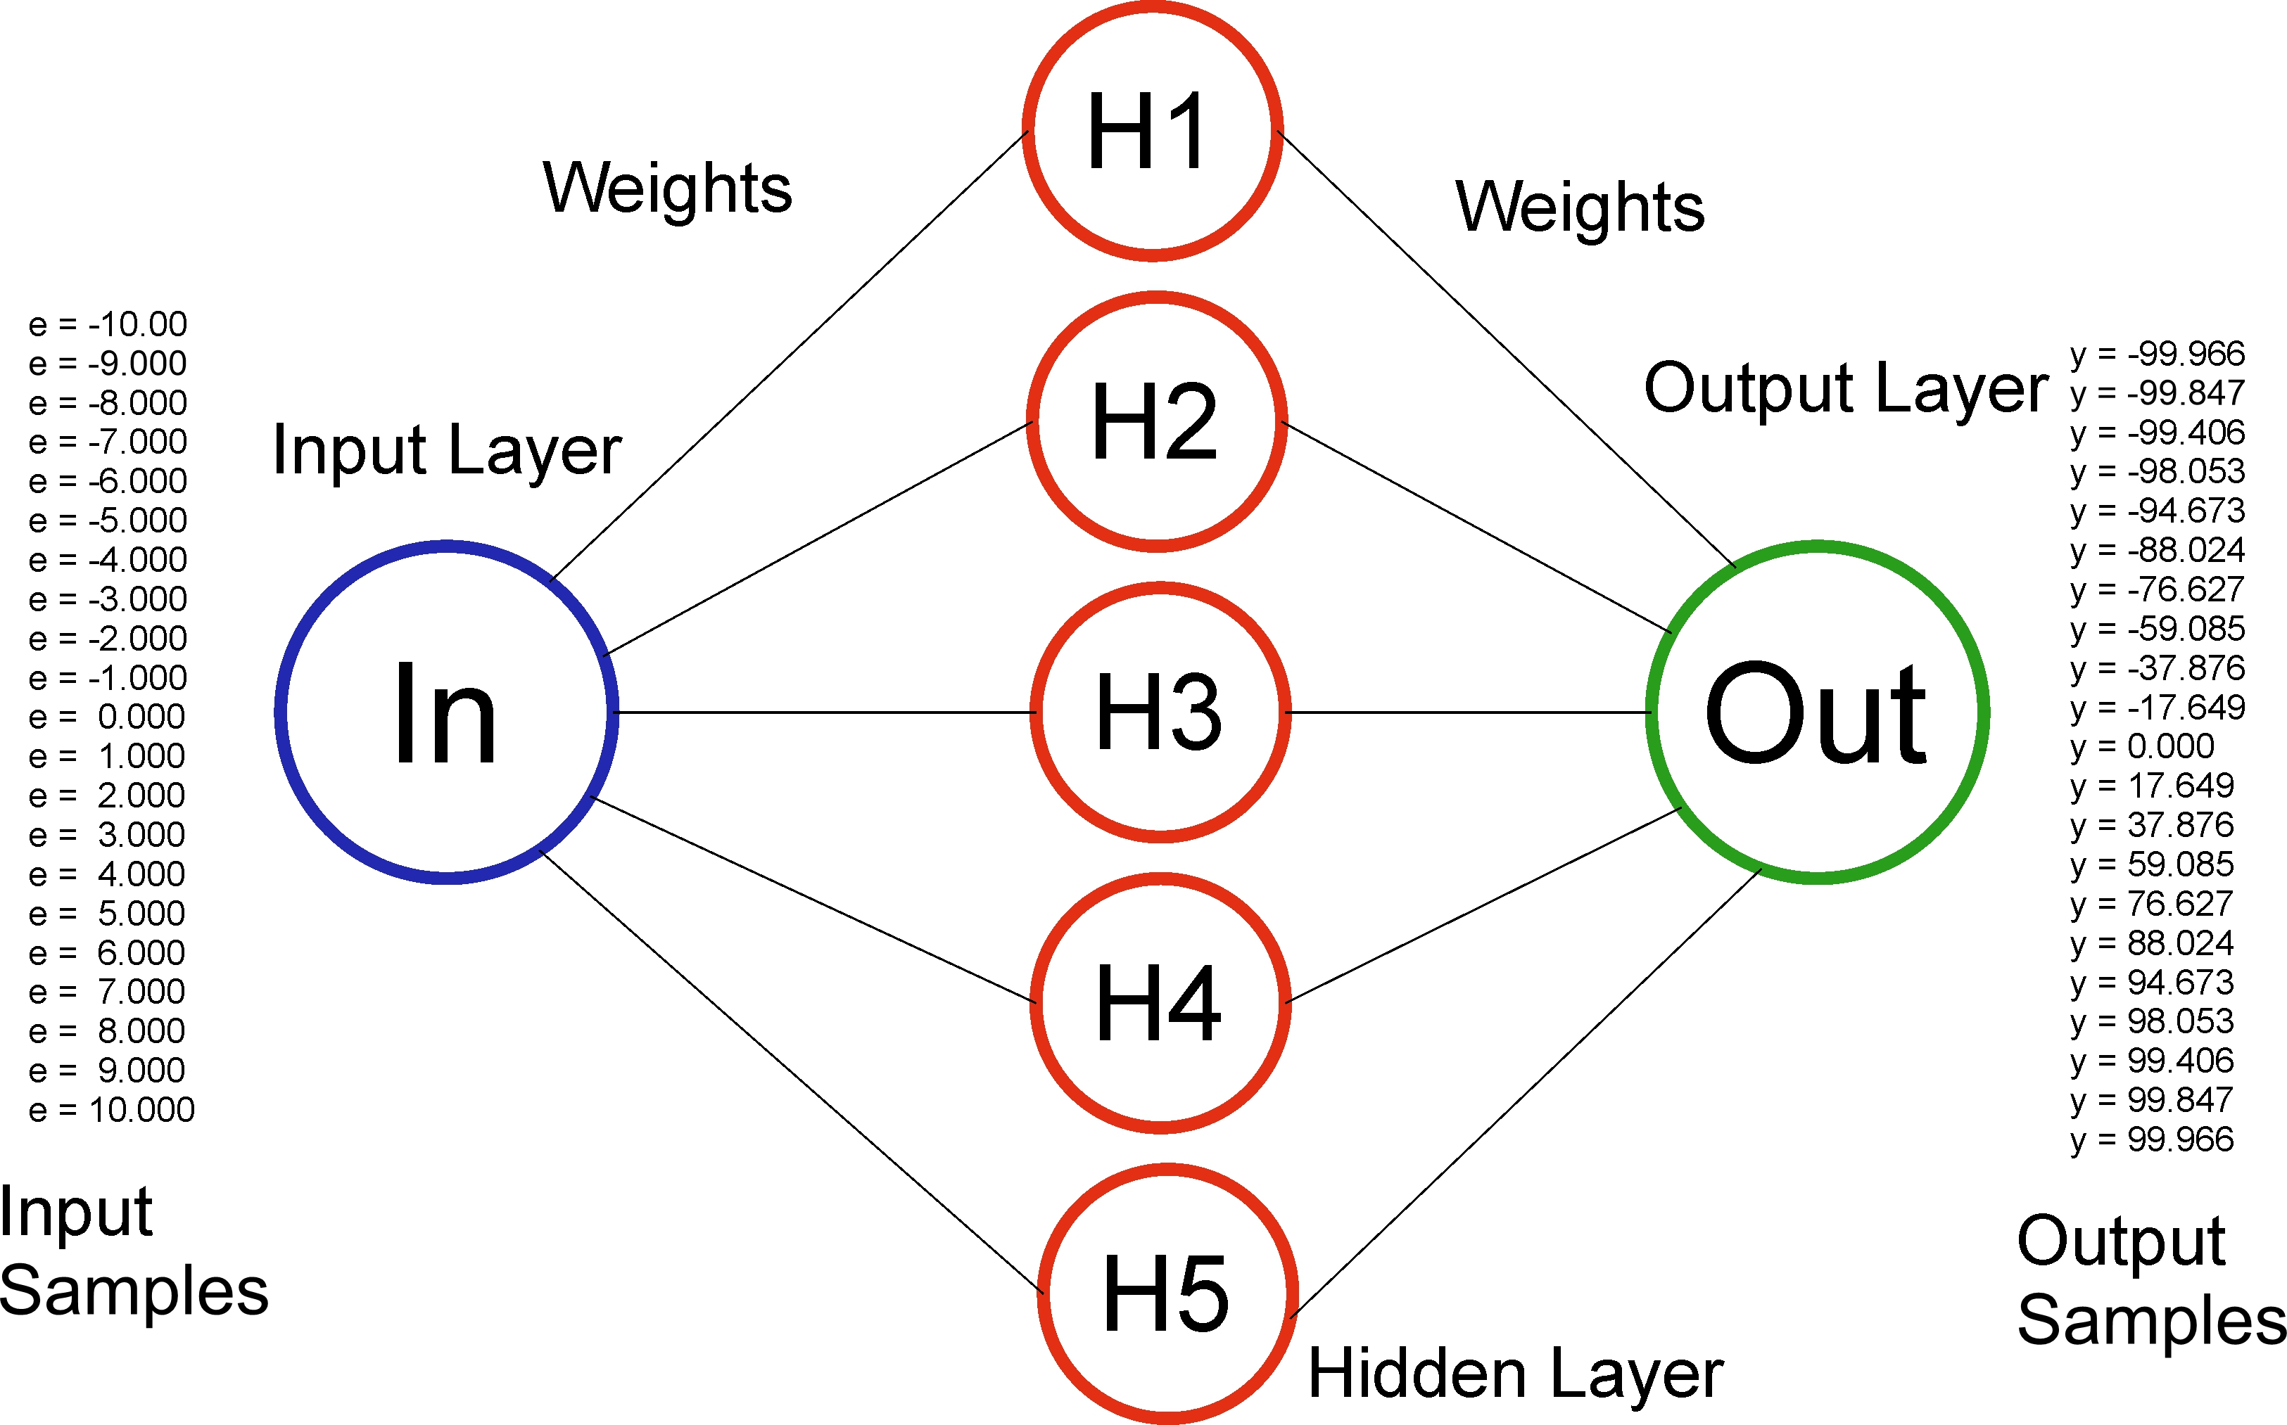
Neural Network with one Input and one Output as well as 5 hidden Neurons

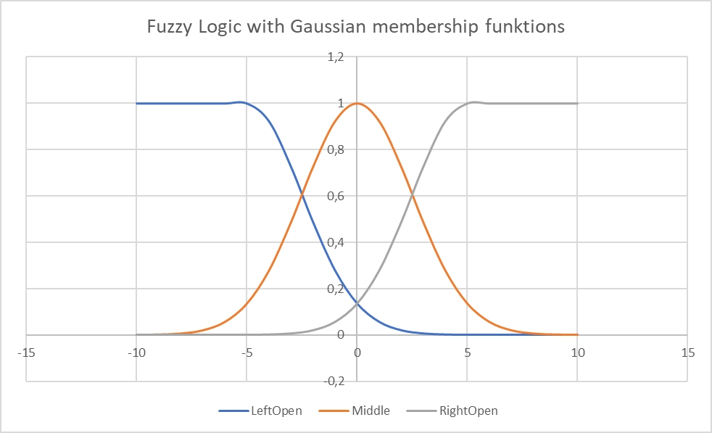
Fuzzy Logic Controller Memberships

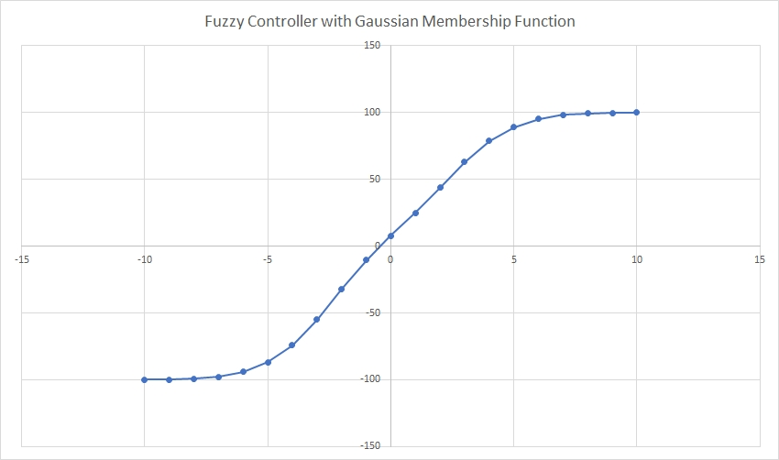
Transfer function of the Fuzzy Controller
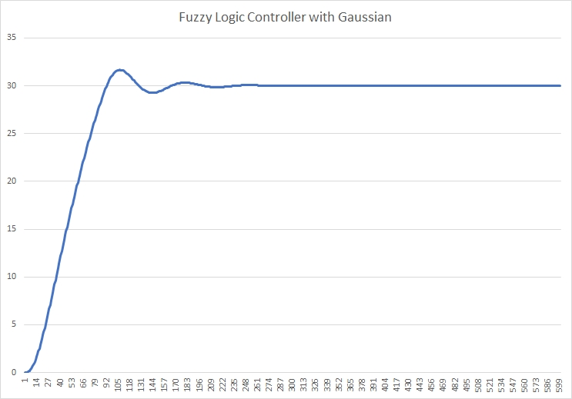
Step Response
A neural network for a fuzzy logic controller:
Neural networks are very suitable for calculating transfer functions. This example is about a fuzzy logic controller (e.g. for Peltier elements) whose transfer function is calculated (Listing 1). This data is used to train a neural network with one input and one output as well as 5 hidden neurons (Listing 2). The data for the transfer function and the values for the hidden layer of the neural network are calculated using an ANSI C program under code blocks on the PC. You can then implement the controller on a microcontroller using this data and a small program. The neural network is also suitable for multiple inputs and outputs.
Listing 1:
/*

Software: Fuzzy Test of Gaussian membership functions

Autor: Josef Bernhardt www.bernhardt.de

Date: 27.01.2023

Codeblocks ANSI C Enviroment for test

E-mail: josef@bernhardt.de for a complete control program

*/

#include <stdio.h>
#include <math.h>

// Mean and standard deviation for the left side of the x axis
float mean_left = -5; // Mean value for the left side of the x axis
float sigma_left = 2.5; // Standard deviation for the left side of the x axis

// Mean and standard deviation for the middle of the x axis
float mean_mid = 0.0; // Mean value for the middle of the x axis
float sigma_mid = 2.5; // Standard deviation for the middle of the x axis

// Mean and standard deviation for the right side of the x axis
float mean_right = 5.0; // Mean value for the right side of the x axis
float sigma_right = 2.5; // Standard deviation for the right side of the x axis

// This function calculates the membership value of a given input
// 'x' in a left-open Gaussian membership function.
// The left-open Gaussian membership function returns 1.0 for
// input values less than the mean,
// and the standard Gaussian membership function value otherwise.
float gauss_membership_leftopen(float x, float mean, float sigma) {
if (x < mean) {
return 1.0; // Outside the interval, return 0
}
return exp(-0.5 * pow((x - mean) / sigma, 2));
}

// This function calculates the membership value of a given input 'x'
// in a standard Gaussian membership function.
// The standard Gaussian membership function is continuous and
// returns a value based on the input, mean, and standard deviation.
float gauss_membership(float x, float mean, float sigma) {
return exp(-0.5 * pow((x - mean) / sigma, 2));
}

// This function calculates the membership value of a given input 'x'
// in a right-open Gaussian membership function.
// The right-open Gaussian membership function returns 1.0 for
// input values greater than the mean,
// and the standard Gaussian membership function value otherwise.
float gauss_membership_rightopen(float x, float mean, float sigma) {
if (x > mean) {
return 1.0; // Outside the interval, return 0
}
return exp(-0.5 * pow((x - mean) / sigma, 2));
}

// This function calculates the control signal (y) based on the error signal (e) using fuzzy logic.
float fuzzy_control(float e) {
// Calculate the membership values for the error signal in different regions of the fuzzy sets.
float left = gauss_membership_leftopen(e, mean_left, sigma_left); // Membership value for the left region
float middle = gauss_membership(e, mean_mid, sigma_mid); // Membership value for the middle region
float right = gauss_membership_rightopen(e, mean_right, sigma_right);// Membership value for the right region

// Calculate the weighted sum of membership values to determine the control signal.
float numerator = left * -70.0 + middle * 10 + right * 70.0; // Weighted sum of membership values
float denominator = left + middle + right; // Sum of membership values

float y; // Control signal

// Avoid division by zero by checking if the denominator is zero.
if (denominator != 0) {
// Calculate the control signal as the ratio of the weighted sum to the sum of membership values.
y = numerator / denominator;
} else {
// If the denominator is zero, set the control signal to zero to avoid undefined behavior.
y = 0;
}

// Uncomment the following line to print the membership values for debugging purposes.
// printf("The membership for e = %.5f, y = %.5f, left = %.5f middle = %.5f right = %.5f\n", e, y, left, middle, right);

return y; // Return the control signal.
}

// This function simulates a second-order system using a discrete-time approach (Euler integration).
float PT2_Simulation(float ControlInput) {
// Parameters
const float deltaT = 1.0; // Time step (max 10)
const float k1 = 82.0 / 100; // Gain factor
const float k2 = 1.0; // Gain factor
const float k3 = 1.0; // Gain factor
const float T1 = 100.0; // Time constant
const float T2 = 8.0; // Time constant
const float T3 = 10.0; // Time constant

// Variables
static float x1_k = 0; // State variable 1 at time k
static float x2_k = 0; // State variable 2 at time k
static float x3_k = 0; // State variable 3 at time k
static float x1_dot; // Rate of change of state variable 1
static float x2_dot; // Rate of change of state variable 2
static float x3_dot; // Rate of change of state variable 3

// Model equations using Euler integration
x1_dot = (k1 * ControlInput - x1_k) / T1; // Rate of change of state variable 1
x1_k = x1_dot * deltaT + x1_k; // Update state variable 1 using Euler integration

x2_dot = (k2 * x1_k - x2_k) / T2; // Rate of change of state variable 2
x2_k = x2_dot * deltaT + x2_k; // Update state variable 2 using Euler integration

x3_dot = (k3 * x2_k - x3_k) / T3; // Rate of change of state variable 3
x3_k = x3_dot * deltaT + x3_k; // Update state variable 3 using Euler integration

return x3_k; // Return the output of the system (state variable 3 at time k)
}

// Main function to demonstrate the fuzzy controller simulation and PT2 system simulation.
int main() {

// Dateinamen festlegen
char *filename = "ascii_values.csv";

// Datei zum Schreiben öffnen
FILE *file = fopen(filename, "w");

// Überprüfen, ob die Datei erfolgreich geöffnet wurde
if (file == NULL) {
printf("Fehler beim Öffnen der Datei.");
return 1;
}

int loop = 0; // Loop counter

float w = 30.0; // Setpoint or desired output
float y = 0; // Output of the system
float x = 0; // Input to the system (state variable)
float e = 0; // Error signal

// fprintf(file,"w x y");

// Loop for PT2 system simulation and fuzzy control
for (loop = 0; loop < 600; loop++) {
// Simulate the PT2 system and calculate the error signal
x = PT2_Simulation(y); // Simulate the PT2 system and update the state variable
e = w - x; // Calculate the error signal

// Apply fuzzy control to calculate the control signal
// Uncomment the following line to apply fuzzy control with a constant offset
y = fuzzy_control(e +2.32); // Apply fuzzy control with a constant offset
// y = fuzzy_control(e); // Apply fuzzy control

// Print epoch information (iteration number) and system variables
printf("epoch = %d w = %.5f, e = %.5f, x = %.5f, y = %.5f \n", loop, w, e, x, y);
// fprintf(file,"epoch = %d w = %.5f, e = %.5f, x = %.5f, y = %.5f \n", loop, w, e, x, y);
fprintf(file,"%.5f %.5f %.5f \n", w, x, y);

}

// Print the difference between the setpoint and the final system output
printf("e = %.5f",e);

// system("pause");
printf("Controller characteristic curve\n");
printf("float trainingPatterns[MAX_PATTERNS][MAX_INPUT_NEURONS] = {");
for (float ll = -10; ll < 11; ll+=1.0)
{
y = fuzzy_control(ll);
printf("{%.5f} , ",ll);
}
printf("};\n");
printf("float targetOutputs[MAX_PATTERNS][MAX_OUTPUT_NEURONS] = {");
for (float ll = -10; ll < 11; ll+=1.0)
{
y = fuzzy_control(ll);
printf("{%.7f}, ",y/100.0);
}
printf("};\n");

// Datei schließen
fclose(file);

system("pause");
return 0; // Return 0 to indicate successful execution
}

/*

Controller characteristic curve

e = -10.000, y = -99.966
e = -9.000, y = -99.847
e = -8.000, y = -99.406
e = -7.000, y = -98.053
e = -6.000, y = -94.673
e = -5.000, y = -88.024
e = -4.000, y = -76.627
e = -3.000, y = -59.085
e = -2.000, y = -37.876
e = -1.000, y = -17.649
e = 0.000, y = 0.000
e = 1.000, y = 17.649
e = 2.000, y = 37.876
e = 3.000, y = 59.085
e = 4.000, y = 76.627
e = 5.000, y = 88.024
e = 6.000, y = 94.673
e = 7.000, y = 98.053
e = 8.000, y = 99.406
e = 9.000, y = 99.847
e = 10.000, y = 99.966

example loop

epoch = 472 w = 30.00000, e = 0.00992, x = 29.99008, y = 36.58100
epoch = 473 w = 30.00000, e = 0.00999, x = 29.99001, y = 36.58207
epoch = 474 w = 30.00000, e = 0.01005, x = 29.98995, y = 36.58303
epoch = 475 w = 30.00000, e = 0.01011, x = 29.98989, y = 36.58385
epoch = 476 w = 30.00000, e = 0.01016, x = 29.98984, y = 36.58455
epoch = 477 w = 30.00000, e = 0.01020, x = 29.98980, y = 36.58515
epoch = 478 w = 30.00000, e = 0.01023, x = 29.98977, y = 36.58562
epoch = 479 w = 30.00000, e = 0.01025, x = 29.98975, y = 36.58596
epoch = 480 w = 30.00000, e = 0.01027, x = 29.98973, y = 36.58619
epoch = 481 w = 30.00000, e = 0.01027, x = 29.98973, y = 36.58630
epoch = 482 w = 30.00000, e = 0.01027, x = 29.98973, y = 36.58630
epoch = 483 w = 30.00000, e = 0.01027, x = 29.98973, y = 36.58619
epoch = 484 w = 30.00000, e = 0.01025, x = 29.98975, y = 36.58599
epoch = 485 w = 30.00000, e = 0.01023, x = 29.98977, y = 36.58568
epoch = 486 w = 30.00000, e = 0.01021, x = 29.98979, y = 36.58529
epoch = 487 w = 30.00000, e = 0.01017, x = 29.98983, y = 36.58480
epoch = 488 w = 30.00000, e = 0.01014, x = 29.98986, y = 36.58424
epoch = 489 w = 30.00000, e = 0.01009, x = 29.98991, y = 36.58362
epoch = 490 w = 30.00000, e = 0.01005, x = 29.98995, y = 36.58294
epoch = 491 w = 30.00000, e = 0.01000, x = 29.99000, y = 36.58221
epoch = 492 w = 30.00000, e = 0.00994, x = 29.99006, y = 36.58142
epoch = 493 w = 30.00000, e = 0.00989, x = 29.99011, y = 36.58060
epoch = 494 w = 30.00000, e = 0.00983, x = 29.99017, y = 36.57975
epoch = 495 w = 30.00000, e = 0.00977, x = 29.99023, y = 36.57888
epoch = 496 w = 30.00000, e = 0.00971, x = 29.99029, y = 36.57800
epoch = 497 w = 30.00000, e = 0.00965, x = 29.99035, y = 36.57713
epoch = 498 w = 30.00000, e = 0.00960, x = 29.99040, y = 36.57625
epoch = 499 w = 30.00000, e = 0.00954, x = 29.99046, y = 36.57541

*/

Listing 2:
/*

Neuronal Net Example with Codeblocks in Ansi C for function approximation
of a Gaussian Fuzzy Controller

Josef Bernhardt

Bad Abbach

josef@bernhardt.de

Date 30.1.2024

Dieses Beispiel verwendet eine einfache zweischichtige Netzwerkarchitektur
mit einer verdeckten Schicht und der TANH-Aktivierungsfunktion.
Die Funktion trainNetwork implementiert den Backpropagation-Algorithmus
für eine einfache Funktion mit 21 Eingangswert, und 21 Ausgangswerten.
Bitte beachten Sie, dass die Lernrate (0.5)
und andere Parameter je nach Anwendungsfall angepasst werden können.

This example utilizes a simple two-layer network architecture with a
hidden layer and the TANH activation function.
The trainNetwork function implements the backpropagation algorithm
for a simple function with 21 input values and 21 output values.
Please note that the learning rate (0.005) and other parameters
can be adjusted according to the application's requirements.

Example Values from Fuzzy Controller with Gaussian Membership Functions

Codeblocks_C_FuzzyMembershipGaussian

*/
#include <stdio.h>
#include <stdlib.h>
#include <math.h>

#define MAX_PATTERNS 21
#define MAX_INPUT_NEURONS 1
#define MAX_HIDDEN_NEURONS 5
#define MAX_OUTPUT_NEURONS 1
#define MAX_EPOCHS 2000000
#define LEARNINGRATE 0.005
#define ERRORTHRESHOLD 0.000125

typedef struct {
// Matrix of weights connecting input neurons to hidden neurons
float inputToHiddenWeights[MAX_INPUT_NEURONS][MAX_HIDDEN_NEURONS];
// Matrix of weights connecting hidden neurons to output neurons
float hiddenToOutputWeights[MAX_HIDDEN_NEURONS][MAX_OUTPUT_NEURONS];
} NeuralNetwork;

// Function to initialize the weights of a neural network
void initializeNetwork(NeuralNetwork *network)
{
// Initialize weights from input neurons to hidden neurons
for (int i = 0; i < MAX_INPUT_NEURONS; ++i) {
for (int j = 0; j < MAX_HIDDEN_NEURONS; ++j) {
// Set weight to a random value between -0.5 and 0.5
network->inputToHiddenWeights[i][j] = ((float)rand() / RAND_MAX) - 0.5;
}
}

// Initialize weights from hidden neurons to output neurons
for (int i = 0; i < MAX_HIDDEN_NEURONS; ++i) {
for (int j = 0; j < MAX_OUTPUT_NEURONS; ++j) {
// Set weight to a random value between -0.5 and 0.5
network->hiddenToOutputWeights[i][j] = ((float)rand() / RAND_MAX) - 0.5;
}
}
}

// Function to initialize the weights of a neural network
void initializeNetworkWithTrainedValues(NeuralNetwork *network)
{
// Input Weights
network->inputToHiddenWeights[0][0]= -0.0766733;
network->inputToHiddenWeights[0][1]= -0.0766415;
network->inputToHiddenWeights[0][2]= -0.2690555;
network->inputToHiddenWeights[0][3]= 0.0766346;
network->inputToHiddenWeights[0][4]= 0.0766677;

// Output Weights
network->hiddenToOutputWeights[0][0]= -1.5407633;
network->hiddenToOutputWeights[1][0]= -1.6960196;
network->hiddenToOutputWeights[2][0]= 1.4115777;
network->hiddenToOutputWeights[3][0]= 2.0167966;
network->hiddenToOutputWeights[4][0]= 1.9217924;

}

void DisplayWeights(NeuralNetwork *network) {
for (int i = 0; i < MAX_INPUT_NEURONS; ++i) {
for (int j = 0; j < MAX_HIDDEN_NEURONS; ++j) {
printf("network->inputToHiddenWeights[%d][%d]= %.7f;\n",i,j,network->inputToHiddenWeights[i][j]);
}
}
printf("\n");
for (int i = 0; i < MAX_HIDDEN_NEURONS; ++i) {
for (int j = 0; j < MAX_OUTPUT_NEURONS; ++j) {
printf("network->hiddenToOutputWeights[%d][%d]= %.7f;\n",i,j,network->hiddenToOutputWeights[i][j]);
}
}
}

float my_exp(float x) {
// Compute the exponential function e^x using Taylor series expansion
float result = 1.0; // Initialize result to 1
float term = 1.0; // Initialize the first term of the series to 1
int i = 1;

// Iterate to sum up terms of the Taylor series until convergence
while (term > 0.0001) { // Adjust the threshold as needed for precision
term *= x / i; // Compute the next term based on the previous term
result += term; // Add the term to the result
i++; // Increment the index for the next term
}

return result;
}

float my_tanh_activation(float x) {
// Compute the hyperbolic tangent (tanh) activation function for the given input x using the formula: (e^x - e^(-x)) / (e^x + e^(-x))
float exp_x = my_exp(x);
float exp_neg_x = my_exp(-x);
return (exp_x - exp_neg_x) / (exp_x + exp_neg_x);
}

float tanh_activation(float x) {
// Compute the hyperbolic tangent (tanh) activation function for the given input x
return tanh(x);
}

void forwardPropagation(NeuralNetwork *network, float input[MAX_INPUT_NEURONS], float hidden[MAX_HIDDEN_NEURONS], float output[MAX_OUTPUT_NEURONS]) {
// Forward propagation from input layer to hidden layer
// Iterate over each hidden neuron
for (int j = 0; j < MAX_HIDDEN_NEURONS; ++j) {
// Initialize net input for the current hidden neuron
float netInput = 0.0;
// Calculate the weighted sum of inputs from input neurons
for (int i = 0; i < MAX_INPUT_NEURONS; ++i) {
netInput += input[i] * network->inputToHiddenWeights[i][j];
}
// Apply activation function (tanh) to the net input and store the result in the hidden layer
hidden[j] = tanh_activation(netInput);
}

// Forward propagation from hidden layer to output layer
// Iterate over each output neuron
for (int k = 0; k < MAX_OUTPUT_NEURONS; ++k) {
// Initialize net input for the current output neuron
float netInput = 0.0;
// Calculate the weighted sum of inputs from hidden neurons
for (int j = 0; j < MAX_HIDDEN_NEURONS; ++j) {
netInput += hidden[j] * network->hiddenToOutputWeights[j][k];
}
// Apply activation function (tanh) to the net input and store the result in the output layer
output[k] = tanh_activation(netInput);
}
}

void backPropagation(NeuralNetwork *network, float input[MAX_INPUT_NEURONS], float hidden[MAX_HIDDEN_NEURONS], float output[MAX_OUTPUT_NEURONS], float targetOutput[MAX_OUTPUT_NEURONS]) {
// Backpropagation for output layer
// Iterate over each output neuron
for (int k = 0; k < MAX_OUTPUT_NEURONS; ++k) {
// Calculate the error between the actual output and the target output
float error = targetOutput[k] - output[k];
// Calculate the gradient of the output neuron's activation function
float outputGradient = 1.0 - output[k] * output[k];
// Update weights connecting hidden layer to output layer
for (int j = 0; j < MAX_HIDDEN_NEURONS; ++j) {
// Update weight using the gradient descent algorithm
network->hiddenToOutputWeights[j][k] += LEARNINGRATE * error * outputGradient * hidden[j];
}
}
// Backpropagation for hidden layer
// Iterate over each hidden neuron
for (int j = 0; j < MAX_HIDDEN_NEURONS; ++j) {
// Initialize hidden layer error
float hiddenError = 0.0;
// Calculate error contributed by each output neuron
for (int k = 0; k < MAX_OUTPUT_NEURONS; ++k) {
hiddenError += (targetOutput[k] - output[k]) * (1.0 - output[k] * output[k]) * network->hiddenToOutputWeights[j][k];
}
// Calculate the gradient of the hidden neuron's activation function
float hiddenGradient = 1.0 - hidden[j] * hidden[j];
// Update weights connecting input layer to hidden layer
for (int i = 0; i < MAX_INPUT_NEURONS; ++i) {
// Update weight using the gradient descent algorithm
network->inputToHiddenWeights[i][j] += LEARNINGRATE * hiddenError * hiddenGradient * input[i];
}
}
}

void trainNetwork(NeuralNetwork *network, float trainingPatterns[MAX_PATTERNS][MAX_INPUT_NEURONS], float targetOutputs[MAX_PATTERNS][MAX_OUTPUT_NEURONS]) {
// Define maximum number of epochs and error threshold
int maxEpochs = MAX_EPOCHS;
float errorThreshold = ERRORTHRESHOLD;

// Iterate over each epoch
for (int epoch = 0; epoch < maxEpochs; ++epoch) {
// Initialize total error for the epoch
float totalError = 0.0;

// Iterate over each training pattern
for (int p = 0; p < MAX_PATTERNS; ++p) {
// Initialize arrays to store input, hidden, and output values for the current pattern
float input[MAX_INPUT_NEURONS];
float hidden[MAX_HIDDEN_NEURONS];
float output[MAX_OUTPUT_NEURONS];

// Copy input values from the training patterns
for (int i = 0; i < MAX_INPUT_NEURONS; ++i) {
input[i] = trainingPatterns[p][i];
}

// Perform forward propagation to calculate the network's output for the current pattern
forwardPropagation(network, input, hidden, output);

// Calculate the error for the current pattern using mean squared error
float patternError = 0.0;
for (int k = 0; k < MAX_OUTPUT_NEURONS; ++k) {
patternError += 0.5 * pow(targetOutputs[p][k] - output[k], 2);
}
// Add pattern error to the total error for the epoch
totalError += patternError;

// Perform backpropagation to update weights based on the error
backPropagation(network, input, hidden, output, targetOutputs[p]);
}
// Check if total error is below the error threshold
if (totalError < errorThreshold) {
printf("Training successful! Epoch: %d, Error: %.8f\n", epoch + 1, totalError);
// Break out of the training loop if training is successful
break;
}
// Print epoch and total error every 10000 epochs
if (epoch % 10000 == 0) {
printf("Epoch: %d, Error: %.8f\n", epoch + 1, totalError);
}
}
}

/*
* This function tests the neural network by computing the output for a set of input patterns and printing it.
*
* Parameters:
* - network: A pointer to the neural network to be tested.
* - inputPatterns: A 2D array of input patterns, where each row represents a pattern and each column represents an input value.
* The size of the array is MAX_PATTERNS x MAX_INPUT_NEURONS.
*/
void testNetwork(NeuralNetwork *network, float inputPatterns[MAX_PATTERNS][MAX_INPUT_NEURONS]) {
for (int p = 0; p < MAX_PATTERNS; ++p) {
float input[MAX_INPUT_NEURONS];
float hidden[MAX_HIDDEN_NEURONS];
float output[MAX_OUTPUT_NEURONS];

// Copy input values for the current pattern from the inputPatterns array
for (int i = 0; i < MAX_INPUT_NEURONS; ++i) {
input[i] = inputPatterns[p][i];
}

forwardPropagation(network, input, hidden, output);
printf("Input: %.3f, Output: %.7f\n", input[0], output[0]);
}
}

void testNetworkOneInput(NeuralNetwork *network, float inputPatterns) {
// Store the single input pattern
float input = inputPatterns;

// Arrays to store hidden and output neuron values
float hidden[MAX_HIDDEN_NEURONS];
float output[MAX_OUTPUT_NEURONS];

// Perform forward propagation to calculate the output based on the input
forwardPropagation(network, &input, hidden, output);

// Print the input and scaled output value (assuming output represents a percentage)
printf("IN: %.5f, OUT: %.2f\n", input, output[0] * 100.0);
}

int main()
{

NeuralNetwork network;

// Values from Codeblocks_C_FuzzyMembershipGaussian
// Controller characteristic curve

float trainingPatterns[MAX_PATTERNS][MAX_INPUT_NEURONS] = {
{-10.00000} , {-9.00000} , {-8.00000} , {-7.00000} , {-6.00000} , {-5.00000} , {-4.00000} ,
{-3.00000} , {-2.00000} , {-1.00000} , {0.00000} , {1.00000} , {2.00000} , {3.00000} ,
{4.00000} , {5.00000} , {6.00000} , {7.00000} , {8.00000} , {9.00000} , {10.00000} , };
float targetOutputs[MAX_PATTERNS][MAX_OUTPUT_NEURONS] = {
{-0.9996647}, {-0.9984682}, {-0.9940568}, {-0.9805257}, {-0.9467336}, {-0.8802415}, {-0.7662693},
{-0.5908495}, {-0.3787581}, {-0.1764929}, {0.0000000}, {0.1764929}, {0.3787581}, {0.5908495},
{0.7662693}, {0.8802415}, {0.9467336}, {0.9805257}, {0.9940568}, {0.9984682}, {0.9996647}, };

initializeNetwork(&network);

// initializeNetworkWithTrainedValues(&network);

printf("Before training:\n");

testNetwork(&network, trainingPatterns);

trainNetwork(&network, trainingPatterns, targetOutputs);

printf("\nAfter training:\n");

testNetwork(&network, trainingPatterns);

for (float x= -10; x < 10.1; x+=0.5)
{
testNetworkOneInput(&network, x);
}

DisplayWeights(&network);

return 0;
}

/*
After training:
Input: -10.000, Output: -0.9968680
Input: -9.000, Output: -0.9939715
Input: -8.000, Output: -0.9877987
Input: -7.000, Output: -0.9743116
Input: -6.000, Output: -0.9448602
Input: -5.000, Output: -0.8833206
Input: -4.000, Output: -0.7682083
Input: -3.000, Output: -0.5906075
Input: -2.000, Output: -0.3779151
Input: -1.000, Output: -0.1761978
Input: 0.000, Output: 0.0000000
Input: 1.000, Output: 0.1761978
Input: 2.000, Output: 0.3779151
Input: 3.000, Output: 0.5906075
Input: 4.000, Output: 0.7682083
Input: 5.000, Output: 0.8833206
Input: 6.000, Output: 0.9448602
Input: 7.000, Output: 0.9743116
Input: 8.000, Output: 0.9877987
Input: 9.000, Output: 0.9939715
Input: 10.000, Output: 0.9968680
*/

/*

IN: -10.00000, OUT: -99.69
IN: -9.50000, OUT: -99.57
IN: -9.00000, OUT: -99.40
IN: -8.50000, OUT: -99.15
IN: -8.00000, OUT: -98.78
IN: -7.50000, OUT: -98.24
IN: -7.00000, OUT: -97.43
IN: -6.50000, OUT: -96.24
IN: -6.00000, OUT: -94.49
IN: -5.50000, OUT: -91.94
IN: -5.00000, OUT: -88.33
IN: -4.50000, OUT: -83.37
IN: -4.00000, OUT: -76.82
IN: -3.50000, OUT: -68.65
IN: -3.00000, OUT: -59.06
IN: -2.50000, OUT: -48.56
IN: -2.00000, OUT: -37.79
IN: -1.50000, OUT: -27.36
IN: -1.00000, OUT: -17.62
IN: -0.50000, OUT: -8.59
IN: 0.00000, OUT: 0.00
IN: 0.50000, OUT: 8.59
IN: 1.00000, OUT: 17.62
IN: 1.50000, OUT: 27.36
IN: 2.00000, OUT: 37.79
IN: 2.50000, OUT: 48.56
IN: 3.00000, OUT: 59.06
IN: 3.50000, OUT: 68.65
IN: 4.00000, OUT: 76.82
IN: 4.50000, OUT: 83.37
IN: 5.00000, OUT: 88.33
IN: 5.50000, OUT: 91.94
IN: 6.00000, OUT: 94.49
IN: 6.50000, OUT: 96.24
IN: 7.00000, OUT: 97.43
IN: 7.50000, OUT: 98.24
IN: 8.00000, OUT: 98.78
IN: 8.50000, OUT: 99.15
IN: 9.00000, OUT: 99.40
IN: 9.50000, OUT: 99.57
IN: 10.00000, OUT: 99.69

Input Weights
network->inputToHiddenWeights[0][0]= -0.0766733;
network->inputToHiddenWeights[0][1]= -0.0766415;
network->inputToHiddenWeights[0][2]= -0.2690555;
network->inputToHiddenWeights[0][3]= 0.0766346;
network->inputToHiddenWeights[0][4]= 0.0766677;

Output Weights
network->hiddenToOutputWeights[0][0]= -1.5407633;
network->hiddenToOutputWeights[1][0]= -1.6960196;
network->hiddenToOutputWeights[2][0]= 1.4115777;
network->hiddenToOutputWeights[3][0]= 2.0167966;
network->hiddenToOutputWeights[4][0]= 1.9217924;

*/

